**INTRODUCTION**

We live in a global world where opportunities are not limited to the country we reside in. We apply for jobs in new cities, start business endeavors across of the globe, and have a seemingly endless list of places we can travel to.

New York City and London are no exception. Both financial centers are filled with booming economies, lively cultural experiences, and a wealth of resources. As such, it is not uncommon for people to consider visiting or even moving there. Say an employee must move from New York City to London to take on a new role at her company. She wants to live in a neighborhood that offers many of the same amenities as her hometown. While the decision to move may be a difficult one, it may be harder to know what neighborhood to settle down in. This comes as no surprise as these metropolises are home to a population of more than 8 million and span roughly 300 square miles and 600 square miles, respectively.

With so many neighborhoods to choose from, it’s tough for an individual to weigh all the options. That’s where the role of data science comes in: we will use the computing power of machines and the insights from statistical models to help the user make a more informed decision. Through this project, a user will be able to see how the various neighborhoods in New York City and London are similar based on the venues they offer.

**DATA SOURCE**

* For the New York City portion of this project, I will be using the data set provided in the IBM lab that is sourced from NYU. The [NYC data set](https://cf-courses-data.s3.us.cloud-object-storage.appdomain.cloud/IBMDeveloperSkillsNetwork-DS0701EN-SkillsNetwork/labs/newyork_data.json) is a json file that contains the names of the neighborhoods as well their boroughs and geographic coordinates.
* For the London portion of this project, I will be using this [Wikipedia](https://en.wikipedia.org/wiki/List_of_areas_of_London) page on areas in London. The data set will be web scraped from the table under “Other use of place names” and for the sake of comparison I will assume the district location is synonymous to the neighborhood value in the NYC data set. This table also contains the names of the boroughs and grid ref geographic coordinates.
* To identify venues within the neighborhoods, I will be using the Foursquare API. I will then conduct an analysis using K-Means clustering across both cities to find similar neighborhoods on the basis of mean venue frequency.

**METHODOLOGY**

Before I began to analyze the data set, I had to extract the relevant information from the data set and transform it into a Pandas data frame. The resulting data frames for New York City and London, respectively, were as follows:

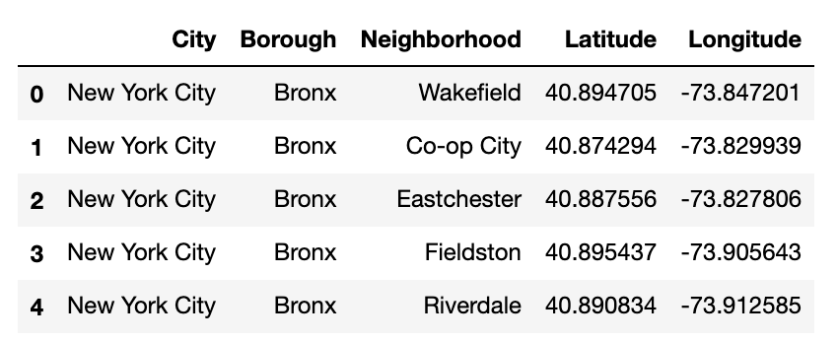

Figure : New York City initial data frame

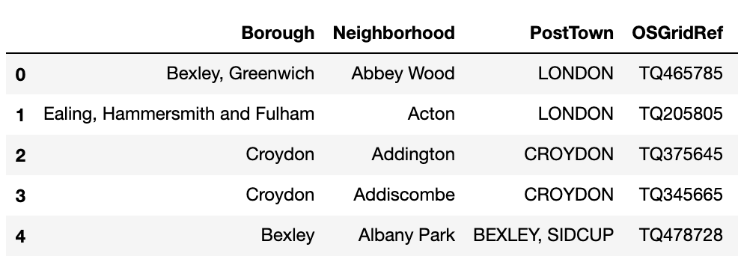

Figure : London initial data frame

In the London data set, I converted the “OSGridRef” to the Latitude and Longitude coordinates using the *OSGridConverter* package and *grid2latlong* library. This was necessary to use the Foursquare API in later steps.

I filtered the London data set to only include the “PostTown” London to narrow down the results from 531 neighborhoods to 297. This was done to try and even the playing field, as New York City has fewer neighborhoods and is a smaller than London.

Upon inspecting the data frame, found that there were neighborhoods with the same name both within and across the two cities. This would become an issue in later steps when I would group the venues by neighborhood. Because the name of the neighborhood would not be considered a unique key, venues would be wrongly merged. To solve this, I concatenated the neighborhood and borough columns. I also added a column to specify the city as the boroughs might not be as well known to the user. The resulting data frame is shown below:

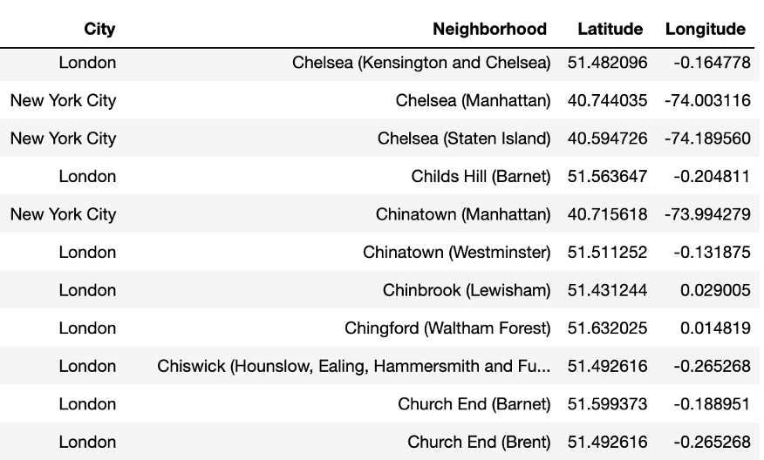

Figure : Combined data frame with updated “Neighborhood” column

I then mapped the cities using *Folium* and added labels to mark the neighborhoods in New York City and London, respectively:

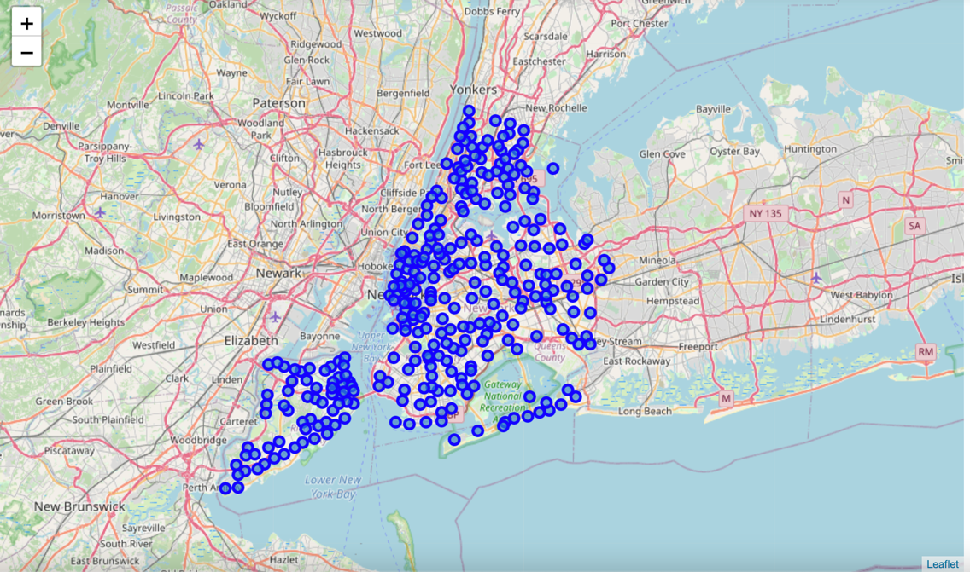

Figure : Map of New York City and its 306 neighborhoods

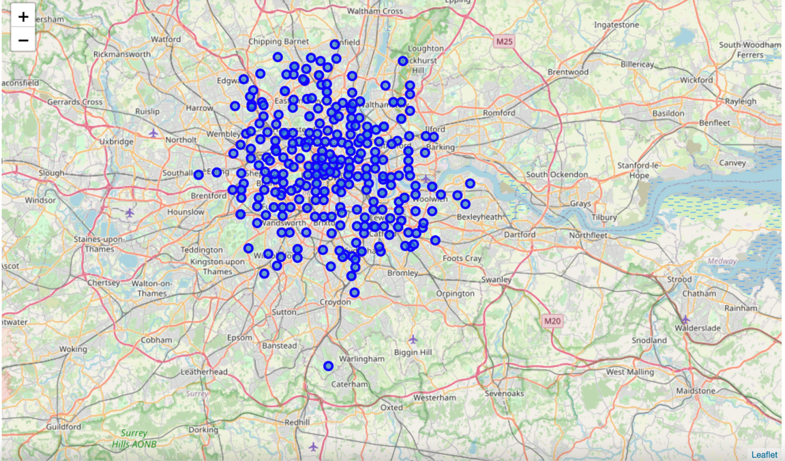

Figure : Map of London narrowed down to 297 neighborhoods

I then used the Foursquare API to get the top 100 venues within a 750-meter (approximately 0.5 mile) radius of the neighborhood. From those 29,507 venues, I extracted the venue category and created a dummy variable for each of the 525 unique categories. After that, I grouped the results by the now unique neighborhood column. I then found the mean frequency of occurrence of each category and focused on the top 10 categories. Lastly, I used K-Mean clustering to group the similar neighbors into 5 clusters.

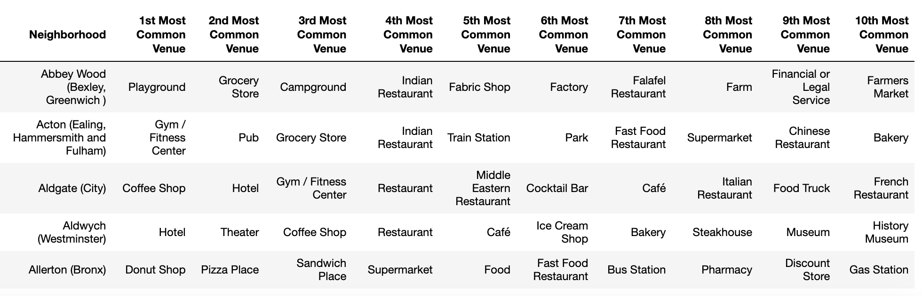

Figure : Top 10 venues per neighborhood using Foursquare API

**RESULTS & DISCUSSION**

These are the 5 different neighborhood clusters:

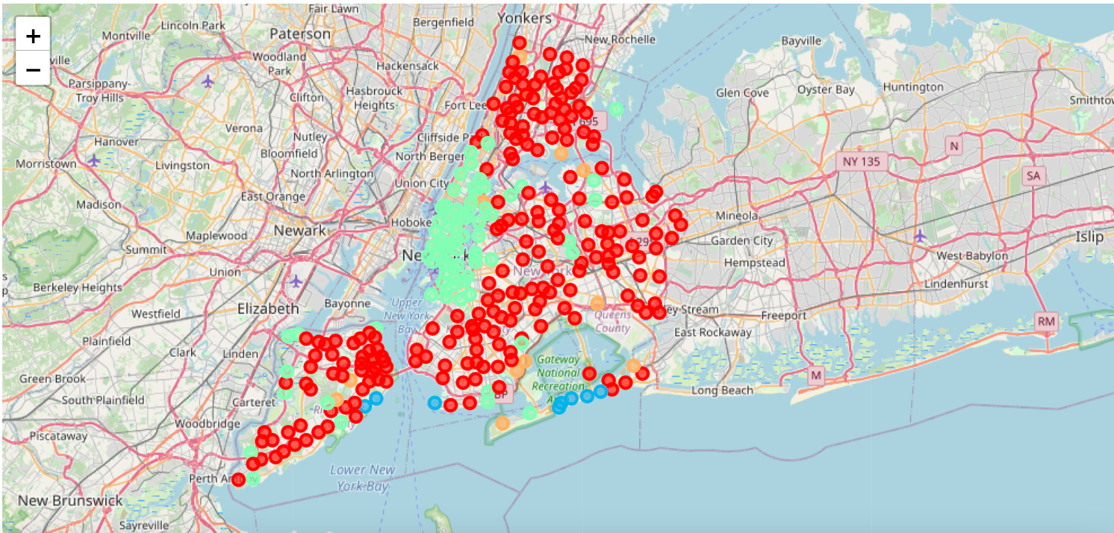

Figure : Cluster map of New York City showing only 4 of the 5 clusters

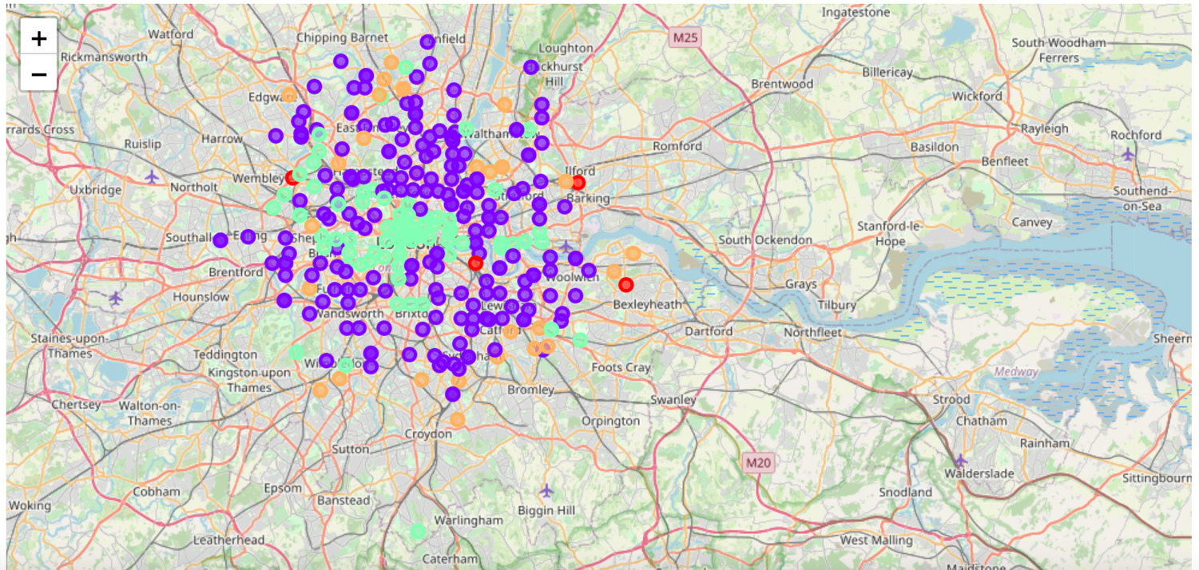

Figure : Cluster map of London showing only 4 of the 5 clusters

To better understand how to label the clusters beyond their colors, let’s examine each cluster:

Red (Cluster 0):

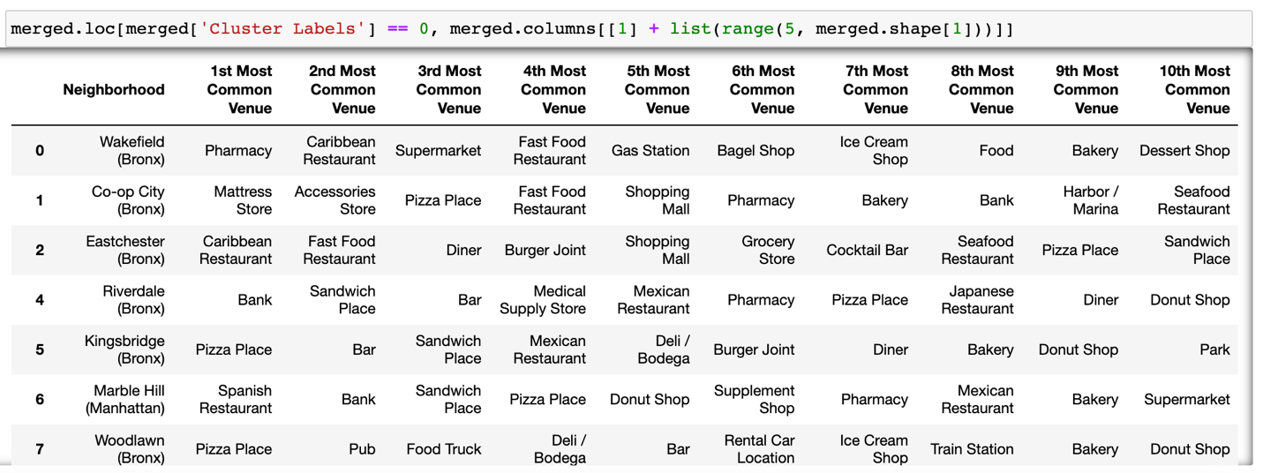

In the Red cluster ***Pizza Places, Delis/Bodegas & Pharmacies*** are the most prevalent. This cluster covers most of the New York City with the exception of the city center. There are very few of these in London. This is not surprising as New York City is known for its pizza and delis/bodegas.

Purple (Cluster 1):

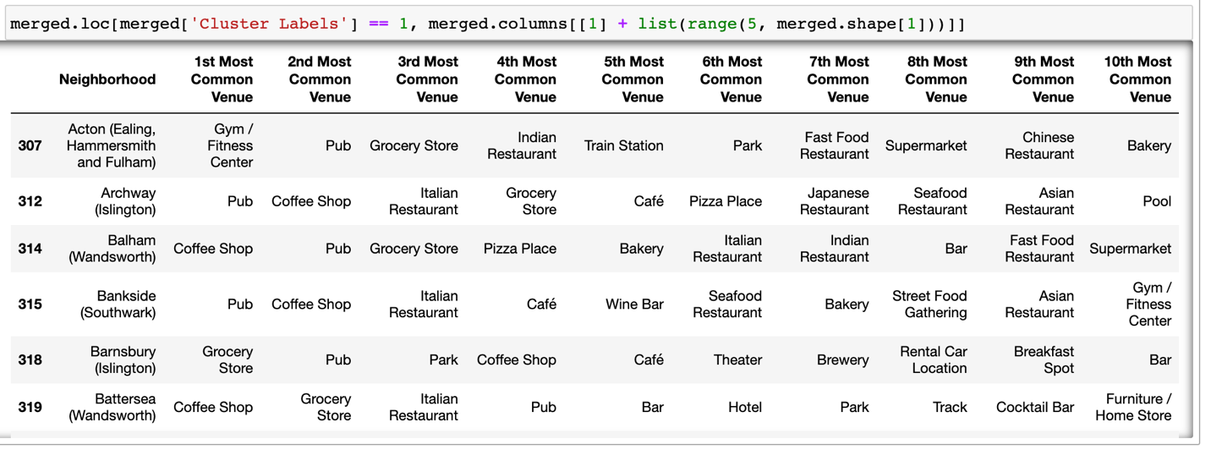

In the Purple cluster ***Pubs, Cafés, Coffee Shops, Grocery Stores & Parks*** are the most prevalent. This cluster covers most London with the exception of the city center. This cluster does not exist in New York City. That’s not to say these venues don’t exist, but rather they are not the most popular types of venues within the neighborhoods in New York City.

Blue (Cluster 2):

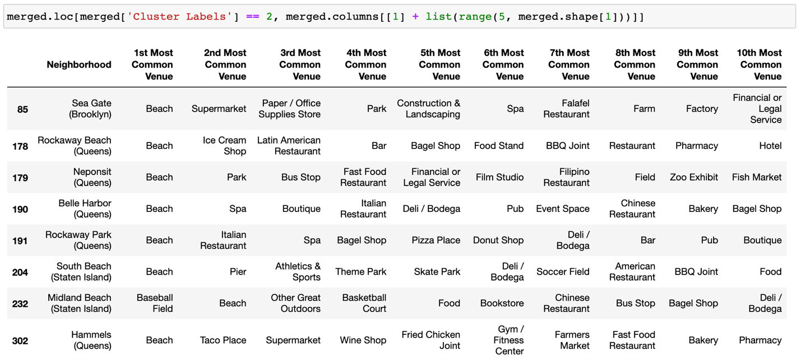

In the Blue cluster ***Beaches*** are the most prevalent. This cluster only exists in New York City and is located on the edges of the city by the water. This makes a lot of sense as New York is located on a natural harbor and surrounded by water, unlike London.

Green (Cluster 3):

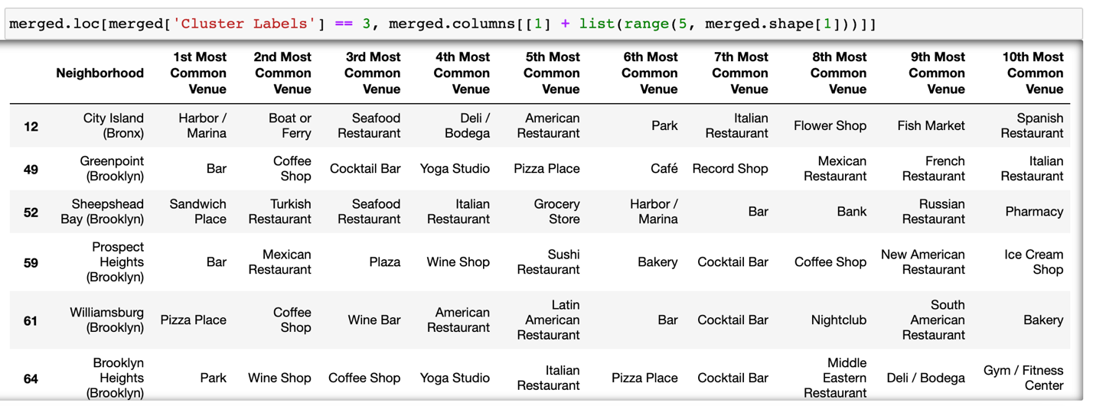

In the Green cluster ***Coffee Shops, Hotels & a variety of other venues*** are prevalent. This cluster only exists in the city centers of New York City and London. This can be explained by the concentration of venues in the heart of the cities that cater to the needs of the residents, workers, and tourists.

Orange (Cluster 4):

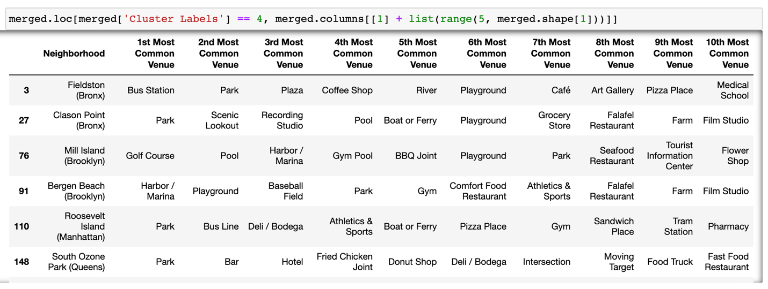

In the Orange cluster ***Parks & Grocery Stores*** are the most prevalent. This cluster exists in the outskirts of New York City and London.

As expected, the neighborhoods in London are more similar to each other than they are to those in New York City, but that’s not to say that you can’t find those same venues. If someone lived in New York City and frequently stopped by a pizza place when visiting her friends, she can still do that in London, but she might have to go down a few blocks. Likewise, the London city center will still have the hustle and bustle of a large city. That’s where the two cities will feel quite similar in their choice of venues. In the future, it would be interesting to group these venues into different categories to understand what sorts of activities are popular in the neighborhood. That way a user can better decide if they want a quiet neighborhood with natural landscapes (beaches, parks, and grocery stores), a neighborhood with a vibrant nightlife (pubs, bars, theaters, concerts), or one with a multitude of food options (restaurants, bakeries, grocery stores).

**CONCLUSION**

As the world continues to become more connected and filled with more and more data, humans will be faced with more decisions to make. We will have to consider more than just a change in venue options. But as these decisions continue to grow more complex, we will have advanced technological capabilities. This will aid in exploring data in a more efficient and effective manner to uncover insights that were nearly impossible or extremely time consuming for humans to do on their own.